Citi Bike Analytics using Tableau

By Blake Skinner

Data Range: Sample of the data from January to December 2018

Data Source: <https://www.citibikenyc.com/system-data>

User Analysis

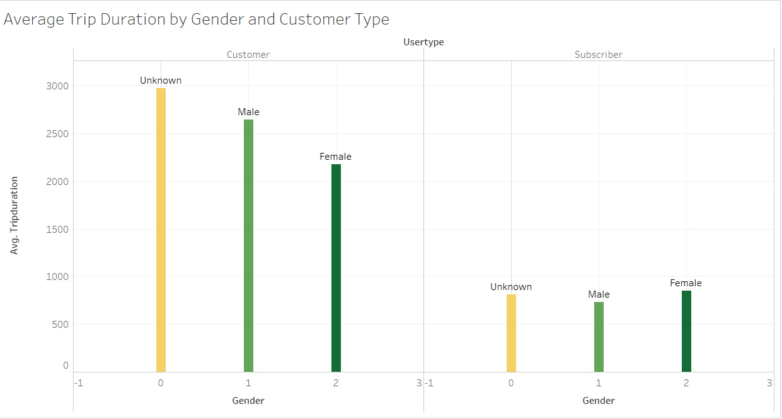

* During 2018, the data shows Females are more likely to commit as a subscriber to CitiBikes over Males, however the majority of the population chooses to not become subscribers so a concerted effort is needed to encourage people to subscribe. It’s possible that potential benefits should be increased for those willing to subscribe.

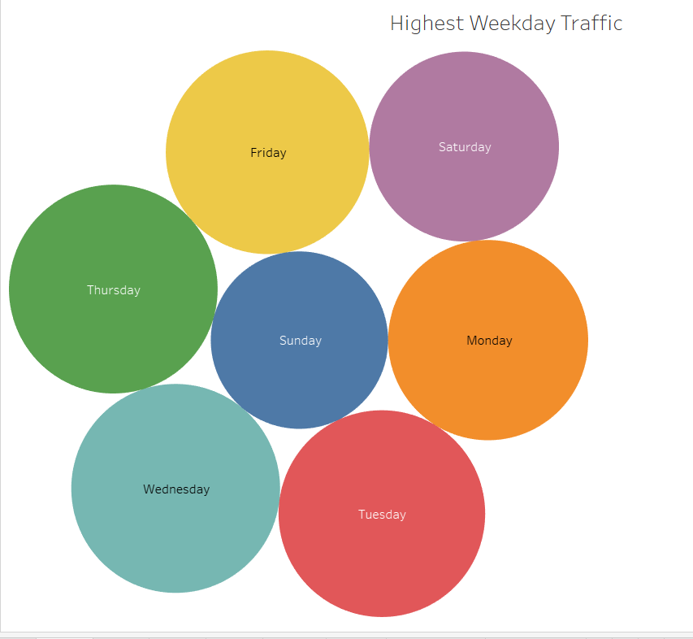

* It is apparent that weekday traffic is fairly even with potential for growth on Saturday and Sunday

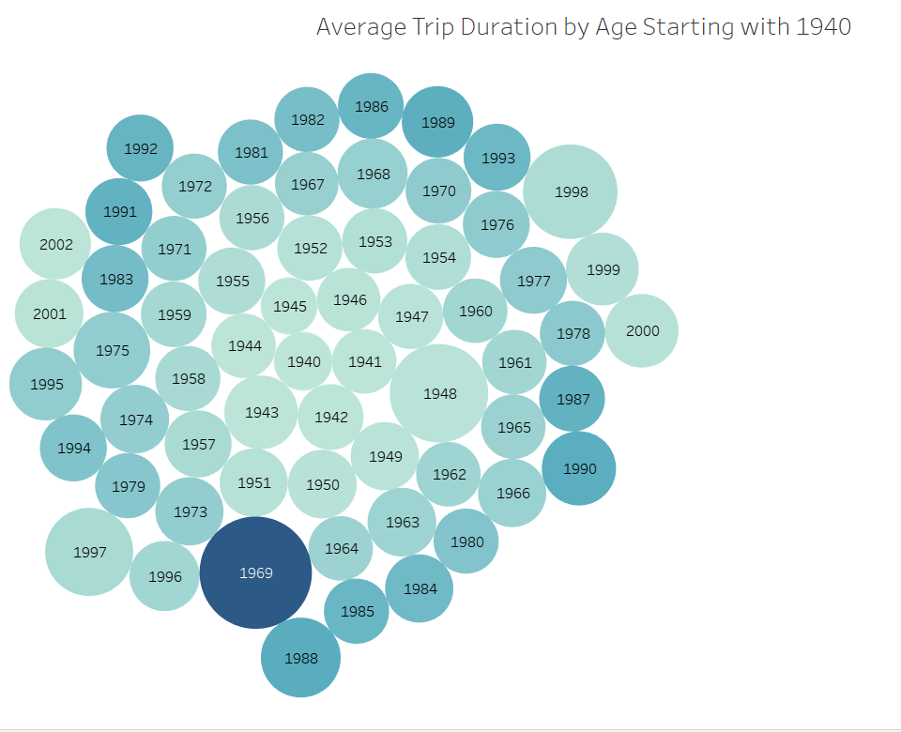

* In this bubble chart we chose to start with the year 1940 to eliminate any outliers from the dataset. From a generational standpoint, it appears that the baby boomers and millennials are more apt to use the bikes where generation x lags. Targeting generation x with marketing could improve that age groups share of usage.
* Potential factors are that more millennials are living in the city and it is more cost effective for them to travel around in this fashion and boomers choose to use the bikes for more of a recreational reason.

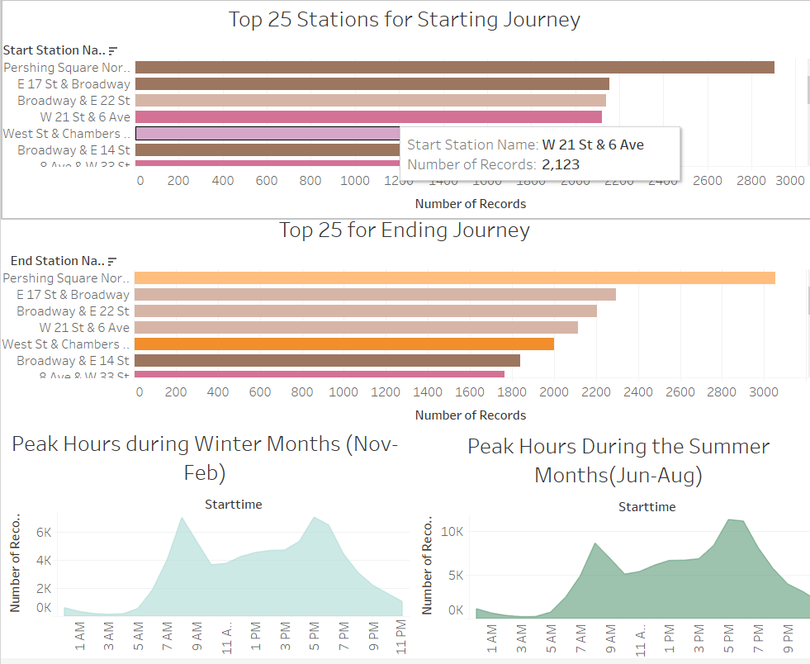

* From the data sample, it appears that most bikes are used for round trips instead of one-way journeys. Also, peak times coincide with typical work schedules no matter the time of year.

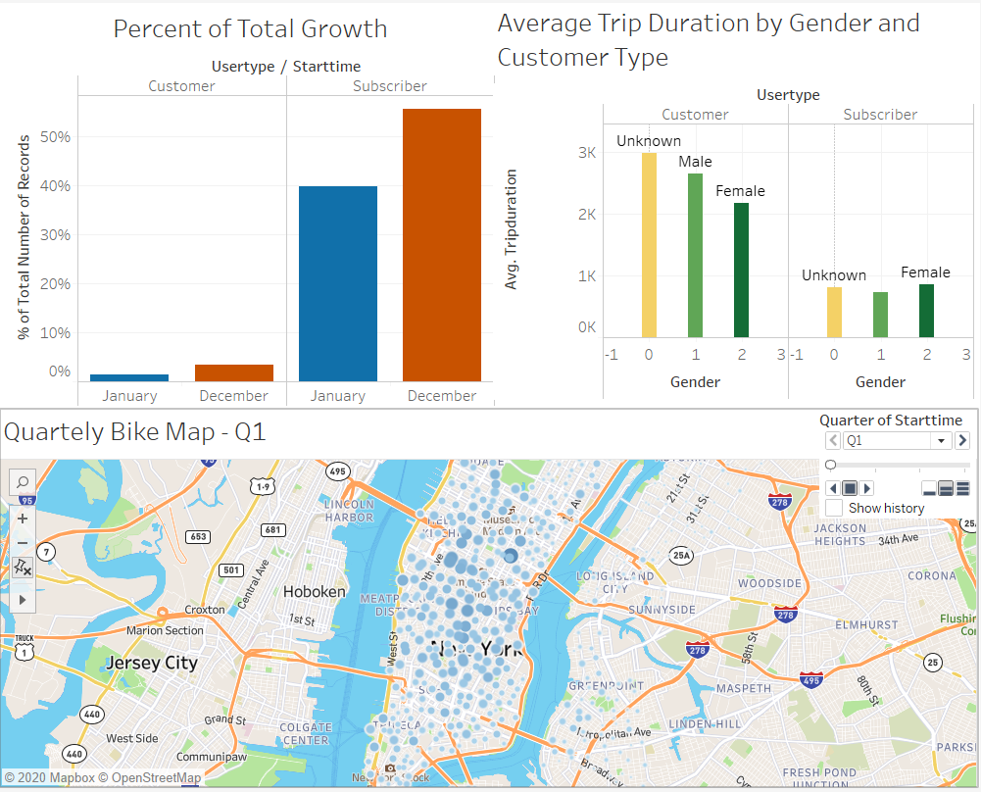

* By the end of 2018, it is evident that subscribers have increased by the month of December. The interactive map shows the busiest stations per quarter in 2018.